Dr. Sachchidanand Sinha
Utility Analysis
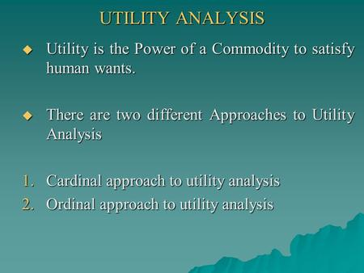
A very important law in consumption relates to the fact that as we go on consuming a commodity, the satisfaction derived from its successive units goes on decreasing.
It is well known that familiarity breeds contempt. The more we have of a commodity, the less we want to have more of it. It is the experience of every consumer that as he goes on consuming a particular commodity, each successive unit of the commodity yields him less and less satisfaction.
In other words, at each step its utility (marginal utility, not total utility) goes on decreasing.
Thus if we are very thirsty and buy a drink to quench our thirst, the drink will yield a great deal of satisfaction at first. After the consumption of the first drink, however, we would not like to have another, because our want has been practically satisfied. This is the case with most of the commodities.
Dr. Marshall states the law thus:
“The additional benefit which a person derives from a given increase of his stock of anything diminishes with the growth of the stock that he has.” In this statement of the law, the word “Additional” is very important. It is only additional (marginal) benefit which decrease and not the total benefit as we shall see in the following table.
The following table relating to an imaginary consumer consuming ‘rasgullas’ illustrates the law:
As the consumer goes on eating ‘rasgullas’, the additional or marginal utility goes on decreasing. The 7th ‘rasgulla’ yields no additional satisfaction and the 8th and 9th have a negative utility (see column 2). Their consumption, instead of giving satisfaction or pleasure, causes dissatisfaction.
- No of rasgullas | - Marginal utility | - Total utility
1 | 15 | 15
2 | 13 | 28
3 | 10 | 38
4 | 8 | 46
5 | 4 | 50
6 | 2 | 52
7 | 0 | 52
8 | -2 | 50
9 | -5 | 45
If we look at column 3, we will find that the total utility goes on increasing up to a point. It also seems reasonable that the utility of two ‘rasgullas” should be more than that of one, and the total utility of three more than that of two, and so on. But if we look at it more carefully, we will notice that although the total utility does does increase, it increases only at a diminishing rate.

For example, when our friend consumes the second ‘rasgulla’, the increase in utility is 13; and when he-consumes the third, the total utility increases by 10 only. Column 2 shows the rate at which utility increases. We can see that it increases at a diminishing rate In other words, the marginal utility decreases. (We shall discuss marginal utility more fully presently).
Diagrammatic Representation:
This law can be understood better with the help of the following diagram:
OX and OY are the two axes. Along OX are represented the units of the commodity, ‘rasgullas’, and along OY is measured the marginal utility corresponding to the consumption of each unit; UU’ is the utility curve. AB is the utility when one ‘rasgulla’ is taken. CD is the additional utility when two of them are taken: CD is less than AB. The additional utilities of other successive Units are EF, GH. KL and MN.
It can be seen that at each step, the additional utility becomes smaller and smaller. At the seventh unit, there is no addition at all, i.e., the marginal utility is zero, and then it becomes negative, which is represented by the shaded area below the axis of X.

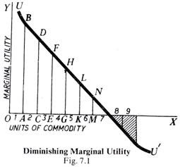
We may distinguish between initial utility, total utility, and zero utility and negative utility.
Initial Utility:
It is the utility of the initial or the first unit. In the table given on the previous page, the initial utility is 15.
Total Utility:
Look at column 3 of the table. It gives the total utility at earn step. For example, if you consume one ‘rasgulla’, the total utility is 15; if you consume two, the total utility is 28, and so on.
Zero Utility:
When the consumption of a unit of a commodity makes no addition to the total utility, then it is the point of zero utility. In our table, the total utility, after the 6th unit is consumed, is 52. At the seventh also it is 52. Thus, the seventh ‘rasgulla results’ in no increase whatsoever. This is the point o’ zero utility, it is thus seen that the total utility is maximum when the marginal utility is zero.
Negative Utility:
If the consumption of a commodity is carried to excess, then instead of giving any satisfaction, it may cause dissatisfaction. The utility in such cases is negative. In the table given above the marginal utility of the 8th and the 9th units is negative.

